ARKVOLT-Installation Incentive Program

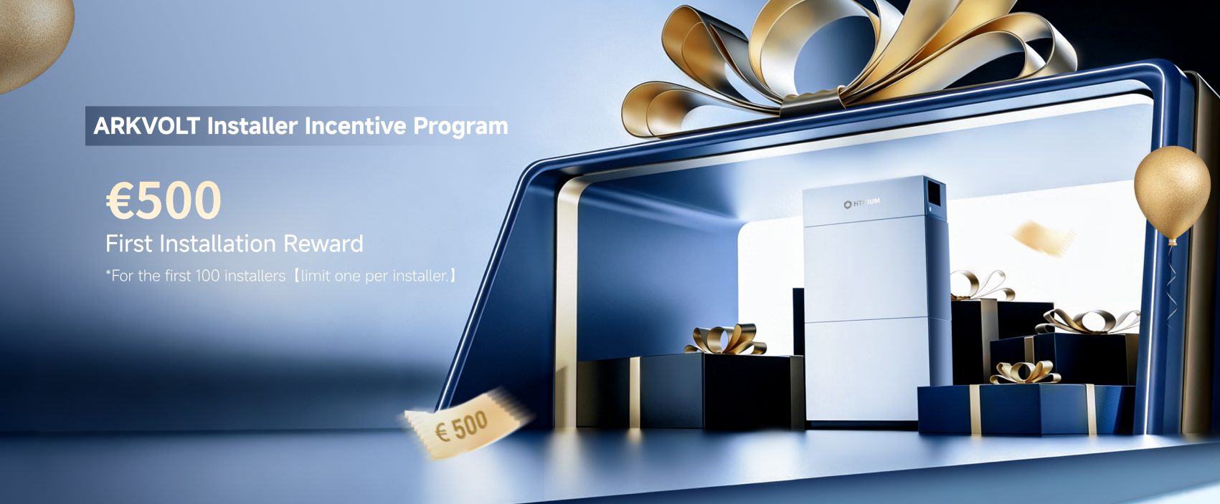
Contact Person
Company Name
Email
SN of Installed Product
Project Photos

*Email format: Please include ARKVOLT in the email subject.
*Please send to this email:：RESS@HITHIUM.COM

https://hithium-arkvolt.com
Shenzhen Hithium Hero Energy Equity Technology Co., Ltd.
Room 101, Building 4, No. 22, Ping'an Road, Guanlan, Zhangxi Community, Guanhu Street,Longhua District, Shenzhen, Guangdong Province, 518000, P.R.China

